**TIẾNG ANH 10 FRIENDS GLOBAL**

**UNIT 6: MONEY**

**SPEAKING TEST**

**Exercise 1: Read the dialogue and choose the correct words. (5 points)**

**Steve** Have you heard that there's a 1**sale** / **coupon** on at WP Arnold's? They're moving to a bigger building so there are loads of 2**bargains** / **price tags**.

**Ben** Yeah, but I've got enough stuff to wear and I can't really afford to buy anything at the moment.

**Steve** I can lend you some money if you like. Yesterday I took back a coat that I’d bought and got a 3**receipt** / **refund**, so I've got plenty of cash now.

**Ben** Don't worry. I'd prefer to 4**owe** / **save up** and spend my own money. I don't really like 5**borrowing** / **lending** from friends.

**Steve** OK, no problem.

|  |  |  |  |  |
| --- | --- | --- | --- | --- |
|  |  |  |  |  |

**Exercise 2:**

1. **Make comparison between two pictures about how they spend money on school activities. Justify your opinion.**
2. 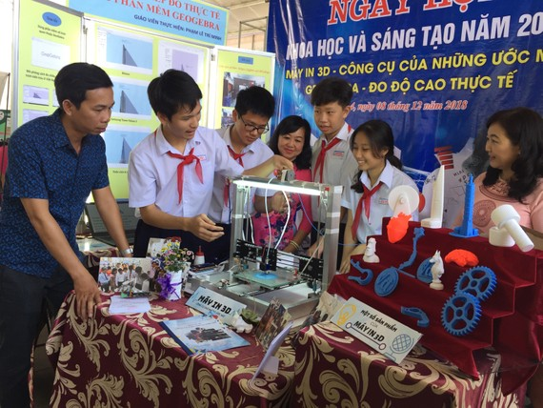 **B.**

**ANSWERS**

Ex 1:

|  |  |  |  |  |
| --- | --- | --- | --- | --- |
| 1. C | 1. E | 1. A | 1. B | 1. D |